

Test Two

Semester One 2017
UNIT 1 METHODS

Calculator Free 35 minutes /30 marks

Only Formula Sheet Permitted
Name:

Place a tick in the box next to your Mathematics teachers name:

Mr Strain | □
Ms Sindel | □
Ms Rimando | □
Ms Reynolds | □
Dr Pearce | □
Mrs Flynn | □
Ms Ensly | □
Mrs Carter | □

Question 1 (3, 3 = 6 marks)
Find the equation of each linear function
- Passing through (2,-3) and (4,1)

- Perpendicular to the line 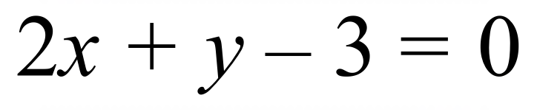 and with x-intercept of -2.

Question 2 (2 marks)
Given the points (-3, 1) and (4, 2) find the exact value of the distance between them.

Question 3 (2 marks)
The gradient of the straight line between (3, y) and (-2, 5) is 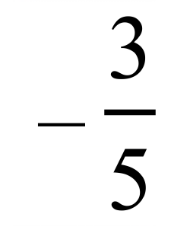 . Find the value of y.

Question 4 (1, 1 = 2 marks)
The quadratic equation 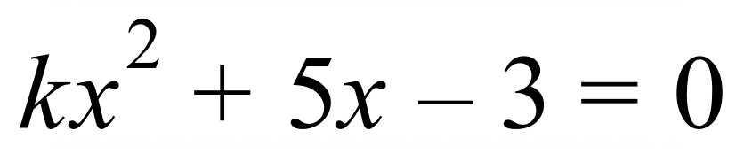 has exactly one real solution.
- What is the value of the discriminant?

- Hence, find the value of k.

Question 5 (2, 2 = 4 marks)
Solve the following quadratic equations giving exact answers
a) 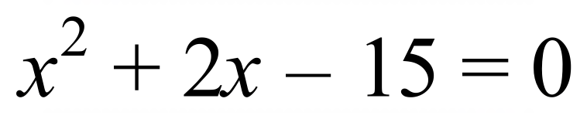

b) 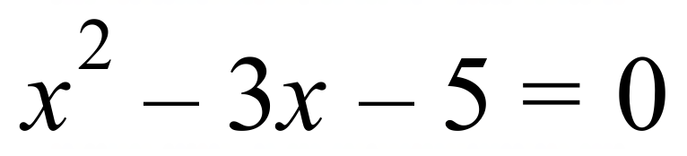

Question 6 (2, 5 = 7 marks)
Determine the rules for the following tables
a)
x | -7 | -6 | -5 | -4 | -3
y | 11 | 10 | 9 | 8 | 7

b)
x | 1 | 2 | 3 | 4 | 5 | 6 | 7
y | 2 | 2 | 4 | 8 | 14 | 22 | 32

Question 7 (3, 2, 2 = 7 marks)
(a) Part of the graph of is shown below.

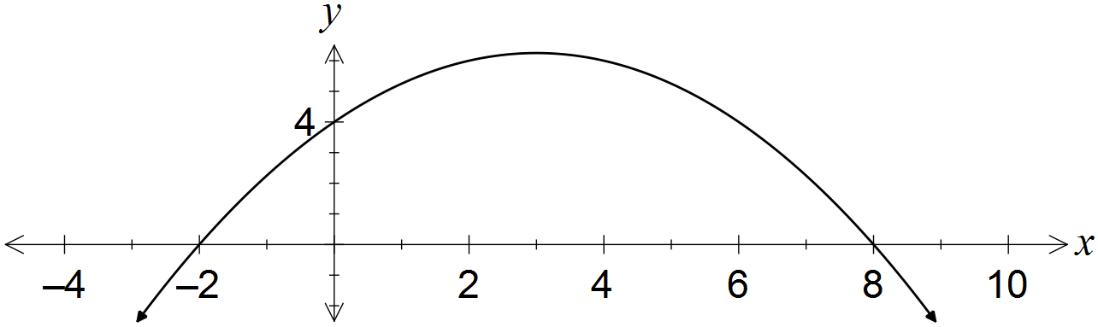

Determine the values of the coefficients a and b.

(b) A quadratic has equation . Determine

(i) the coordinates of its turning point.

(ii) the exact values of the zeros of the quadratic.

